Fan Hub Plus Technical Documentation
Project Title: Fan Hub Plus
Frontend Stack: React 19, Vite 8, Tailwind CSS v4, Lucide React
Backend Stack: Python 3, Django 5, Django REST Framework (DRF), SimpleJWT, Google GenAI SDK
Database Engine: SQLite3 (db.sqlite3, Pre-Seeded Default) / MySQL 8.0+ Compatible (seed_data.sql)
API Versioning: Dual-mounted at /api/ and /api/v1/
Team Name: TECH VANGUARD
Team Members
S/N | StudentID | Fullname | Contact | Email
1 | Student1436895 | Haleem Opeyemi Akintayo | 09060251750 | haleemcoco14@gmail.com
2 | Student1537095 | Mayowa Abdulbasit Ojure | 07081169461 | mayowaabdulbasit05@gmail.com
3 | Student1524611 | Marvellous Ayobami Olaokun | 09157404272 | marvellousolaokun@gmail.com
4 | Student1647016 | Moroufoluwa David Ibitokun | 09019979189 | ibitokunmoro3@gmail.com

Table of Contents
- Problem Definition
- Design Specifications
- System Diagrams (Architecture, DFDs, Activity Flowcharts & Sequence Diagrams)
- Database Design, Schema Diagrams & Data Dictionary
- Comprehensive Feature Breakdown & Screenshot Placeholders
- Test Data Used in the Project & Verification Matrix
- Project Installation Instructions & Running the App Locally (MANDATORY)
- User Credentials for All Types of Users with Passwords (MANDATORY)
- RESTful API Endpoint Reference
1. Problem Definition
1.1 Background & Industry Context
Modern pop-culture fandoms spanning Anime, Gaming, Movies & TV, K-Pop, Comics, Manga, Cosplay, and Community Scholarship generate massive volumes of lore analyses, audiovisual media, character biographies, collectible releases, and global convention schedules. Despite this rapid growth, the digital experience for fans and collectors remains severely fragmented.
1.2 Core Problems Addressed
- Severe Platform Fragmentation: Enthusiasts must jump between dozens of disconnected websites ad-heavy fan wikis for character lore, YouTube/SoundCloud for trailers and OSTs, separate spreadsheets for comic reading orders, and scattered social media threads for convention dates or merchandise drop times.
- Unverified Spoilers & Low-Quality Content Clutter: Open user-edited wikis and unmoderated forums frequently expose readers to unverified canon theories, toxic comment sections, and low-effort spam because there is no structured administrator moderation pipeline before fan contributions go live.
- Lack of Personal Collector Organization Tools: Existing portals rarely allow users to bookmark cross-format items (articles, character profiles, 4K trailers, audio tracks, and merchandise drops) into a single personal vault while attaching private study notes or pre-order reminders to each saved item.
- Poor Visual Hierarchy & Accessibility Fatigue: Legacy wiki layouts suffer from cramped typography, low contrast, jarring layout shifts, and a lack of accessible font-scaling or zero-flash dark mode switches.
- Commercial Checkout Distractions: Collectors looking to track upcoming figure releases, vinyl boxsets, or cosplay prop blueprints are forced onto transactional e-commerce storefronts rather than a dedicated, non-commercial discovery archive.
1.3 Proposed Solution & Project Objectives
Fan Hub Plus resolves these challenges by providing a unified, full-stack Neo-Brutalist Command Center built around eight distinct fandom universes. Its core engineering objectives are:
- Unified 8-Universe Architecture: Organize curated and community-approved content across Anime, Gaming, Movies & TV, K-Pop, Comics, Manga, Cosplay, and the Community Vault.
- Three-Tier Role-Based Access Control (RBAC): Support seamless progression from Unauthenticated Visitors to Registered Users (Collectors) and Platform Administrators.
- Moderator-Gated Community Canon: Allow registered users to submit fan essays and character dossiers that enter a structured PENDING moderation queue, automatically publishing to the live database upon 1-click administrator approval.
- Personalization & Collector Note-Taking: Provide every registered user with a customizable /dashboard featuring favorite fandom filters, chronological activity logs, and inline personal notes on bookmarked items.
- Hybrid AI Lore Assistant (FandomBot): Combine a deterministic sub-20ms database FAQ engine with Google Gemini 2.5 Flash AI fallback to answer canon questions and recommend reading/viewing orders.
- Strict Non-Transactional Scope: Deliver a pure discovery and archival experience for merchandise and conventions (live UTC countdown clocks, popularity tracking, Haversine GPS convention filtering, and .ics calendar exports) with zero payment gateways, shopping carts, or billing fields.

2. Design Specifications
2.1 Architectural Pattern
Fan Hub Plus follows a decoupled Client-Server REST Architecture:
- Presentation Layer (Frontend SPA): Built with React 19 and Vite 8, utilizing a custom client-side router supporting path-based navigation (/, /dashboard, /admin, /universe/:slug, /article/:slug) and hash-based section jumping (#explore, #multimedia, #characters, #merch, #events).
- Application & Business Logic Layer (Backend API): Built with Django 5 and Django REST Framework (DRF), organized into six domain-driven apps (accounts, fandoms, interactions, merchandise, events, chatbot).
- Data Persistence Layer: Powered by SQLite3 (db.sqlite3) out of the box for zero-configuration local execution, with full MySQL 8.0+ compatibility via Django ORM and a standalone SQL seed script (seed_data.sql).
2.2 Neo-Brutalist UI/UX & Accessibility Specifications
The user interface implements a high-contrast Neo-Brutalist design system engineered for clarity, scannability, and tactile feedback:
Design Token Category | Specification | Implementation Detail
Structural Borders | Hard 2px & 3px solid borders | border-2 border-black dark:border-neutral-100 on all cards, inputs, buttons, and modals
Offset Shadows | Solid non-blurred geometric shadows | shadow-[4px_4px_0px_0px_#000000] (Light) / shadow-[4px_4px_0px_0px_#F3F4F6] (Dark)
Interactive States | Mechanical press translation | hover:-translate-y-0.5 active:translate-x-[2px] active:translate-y-[2px]
Light Theme Canvas | Warm archival paper & ink | Background #FDFBF7, Cards #FFFFFF, Primary Text #111111
Dark Theme Canvas | Deep obsidian cyber-slate | Background #0D1117, Cards #161B22, Primary Text #F9FAFB
Font-Size Scaler | Root HTML accessible scaling | Header A- / A+ toggle switching root font size between 16px (normal) and 18.5px (large)
Loading States | Brutalist geometric skeletons | BrutalCardSkeleton & BrutalGridSkeleton prevent layout shift (CLS) during API calls
2.3 Fandom Universe Color Coding Specification
Each of the 8 mandatory fandom universes is assigned a dedicated high-contrast accent color used consistently across badges, borders, progress bars, and filter pills:
# | Universe Name | URL Slug | Hex Accent Color | Lucide Icon | Seeded Top Pick
1 | Anime | anime | #A3E635 (Acid Lime) | Tv | Solo Leveling: Arise
2 | Gaming | gaming | #FACC15 (Cyber Yellow) | Gamepad2 | Elden Ring: Nightreign
3 | Movies & TV | movies-tv | #38BDF8 (Electric Cyan) | Film | Avengers: Secret Wars Timeline
4 | K-Pop | kpop | #F43F5E (Hyper Rose) | Mic2 | NewJeans Global Tour
5 | Comics | comics | #FB7185 (Crimson Coral) | Zap | Ultimate Spider-Man 2026
6 | Manga | manga | #FB923C (Solar Orange) | BookOpen | Berserk Legacy Continuation
7 | Cosplay | cosplay | #C084FC (Neon Violet) | Sparkles | WCS 2026 Champion Armor
8 | Community Vault | community-vault | #34D399 (Emerald Mint) | ShieldCheck | The Multiverse Paradox Thesis
2.4 Security, Authentication & Resilience Specifications
- JWT Authentication (SimpleJWT): Access tokens (60-minute lifetime) and Refresh tokens (7-day lifetime with rotation). The frontend API client (src/services/api.js) automatically injects Authorization: Bearer <token> headers and transparently retries 401 Unauthorized requests using /api/accounts/token/refresh/.
- Role-Based Route Guards: Backend views enforce IsAuthenticated and custom IsAdminRole permissions (user.role == 'ADMIN' or user.is_superuser). Frontend routes guard /dashboard and /admin with instant role verification.
- Offline-Resilient Hybrid Hydration: All public discovery modules initialize with rich curated fallback data (src/data/fandomData.js) and seamlessly merge/hydrate with live backend SQLite/MySQL records when the API responds.

3. System Diagrams (Architecture, DFDs, Activity Flowcharts & Sequence Diagrams)
3.1 High-Level System Architecture Diagram
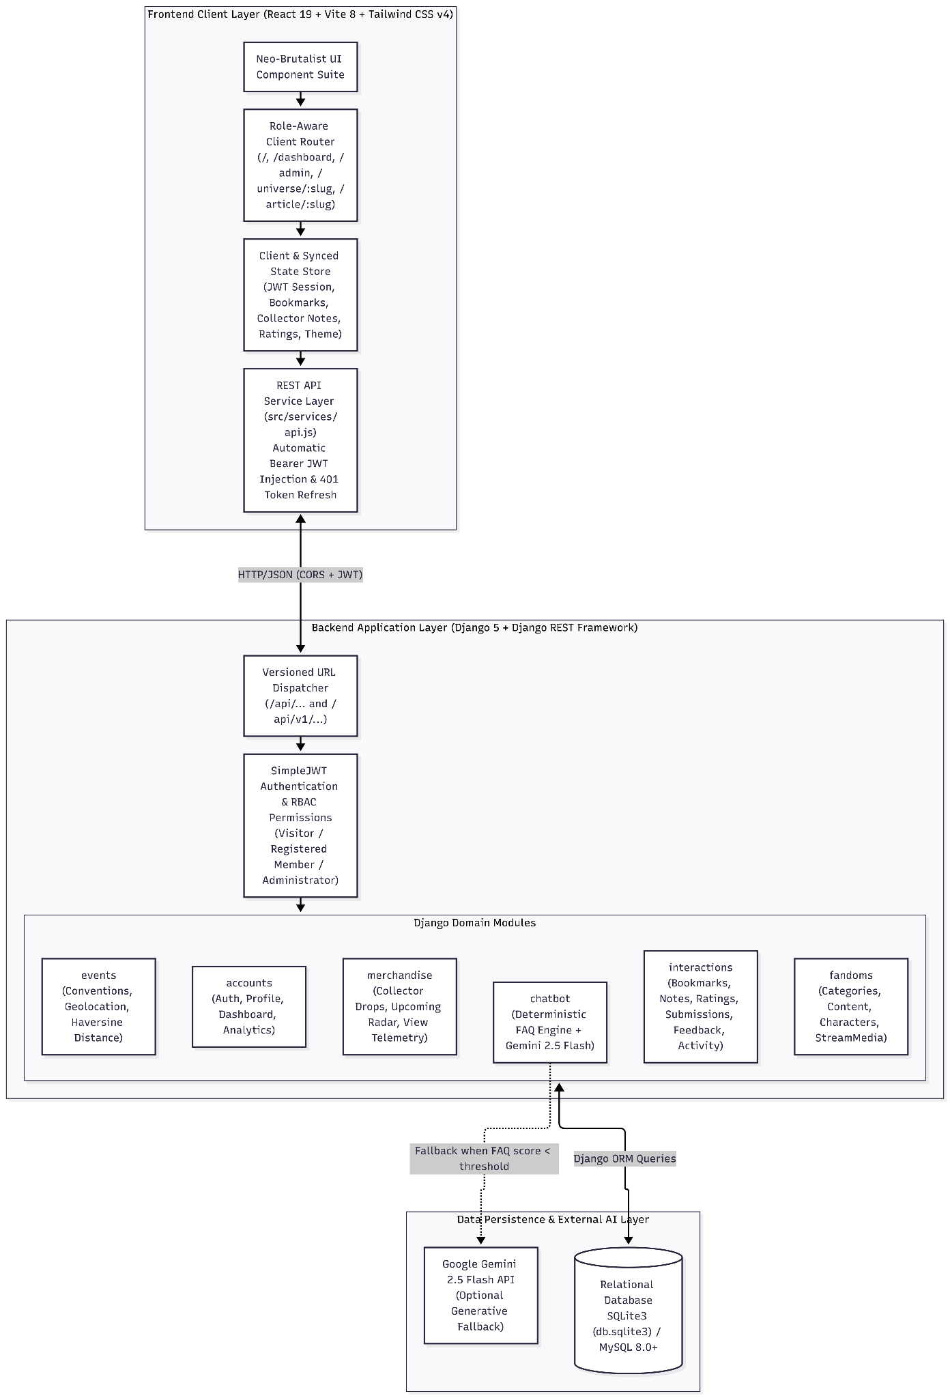
3.2 Data Flow Diagrams (DFD Level 0 & Level 1)
3.2.1 DFD Level 0: Context Diagram
The Context Diagram illustrates how the three external entities (Visitor, Registered User, and Administrator) interact with the central Fan Hub Plus System.
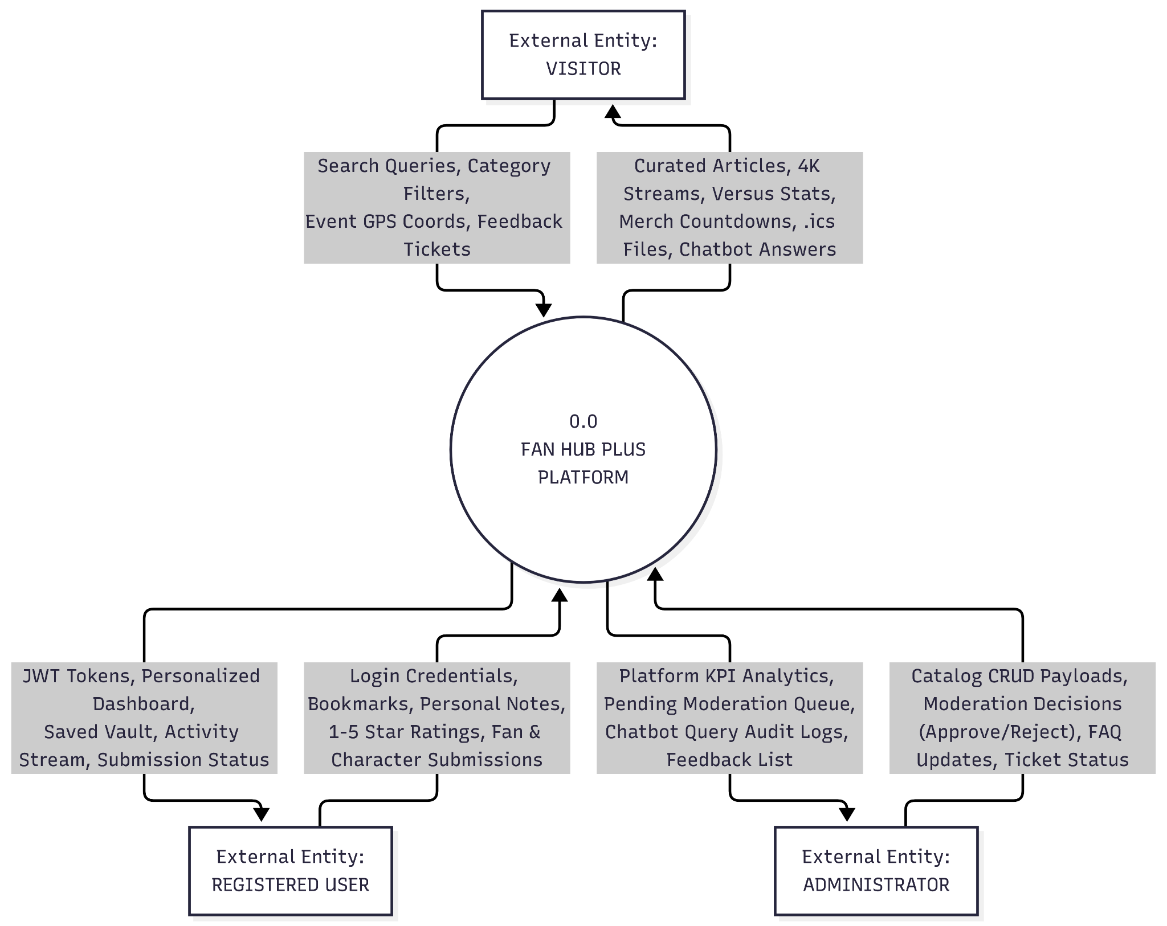

3.2.2 DFD Level 1 — System Process & Data Store Decomposition
The Level 1 Data Flow Diagram decomposes the system into six core functional processes (P1.0 to P6.0) and six relational data stores (D1 to D6).
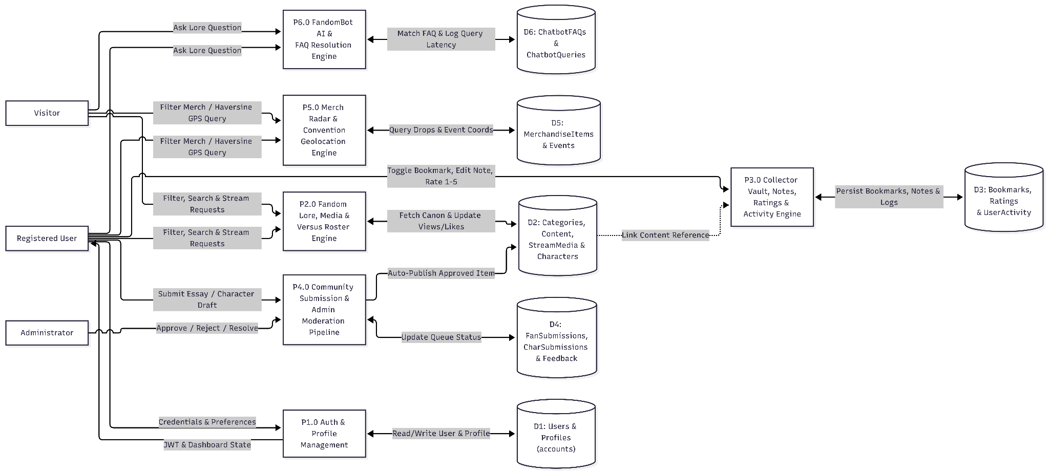

3.3 Activity Flowcharts for Core Platform Workflows
3.3.1 Activity Flowchart 1 — User Authentication, Registration & Role Routing
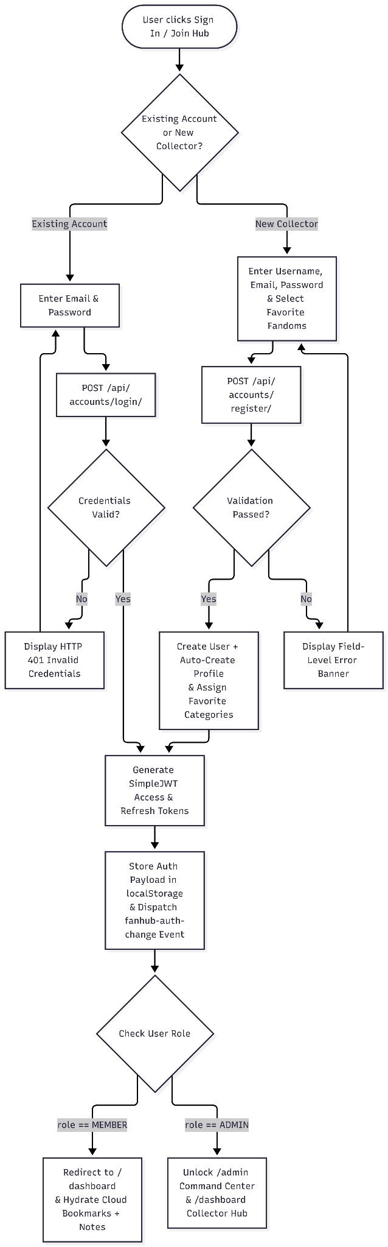

3.3.2 Activity Flowchart 2: Multi-Level Content Exploration, Bookmarking & Personal Note Workflow
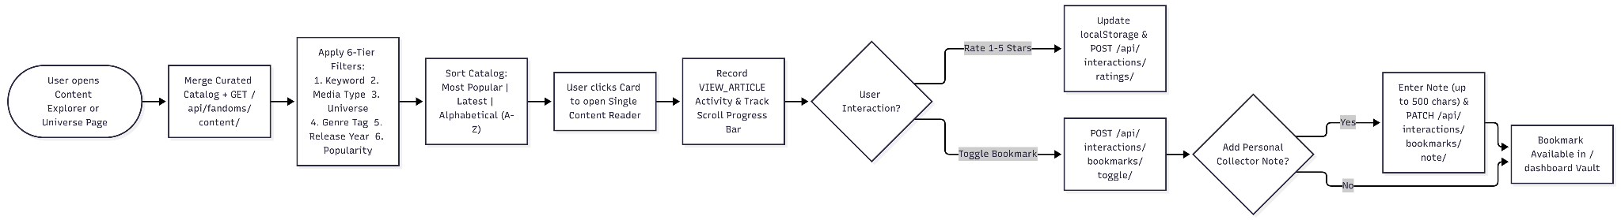

3.3.3 Activity Flowchart 3: FandomBot AI Hybrid Lore Resolution
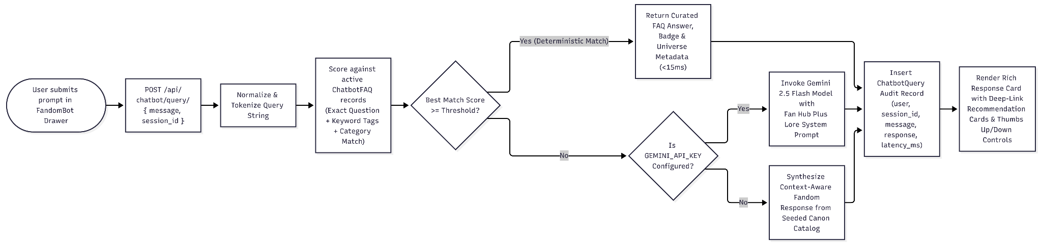

3.3.4 Activity Flowchart 4: Convention Radar Geolocation (Haversine) & .ics Export
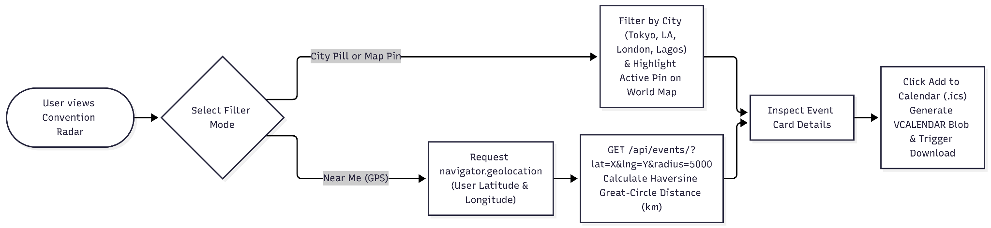

3.4 Sequence & State Lifecycle Diagrams
3.4.1 Sequence Diagram: Community Submission to Admin Approval & Live Publication
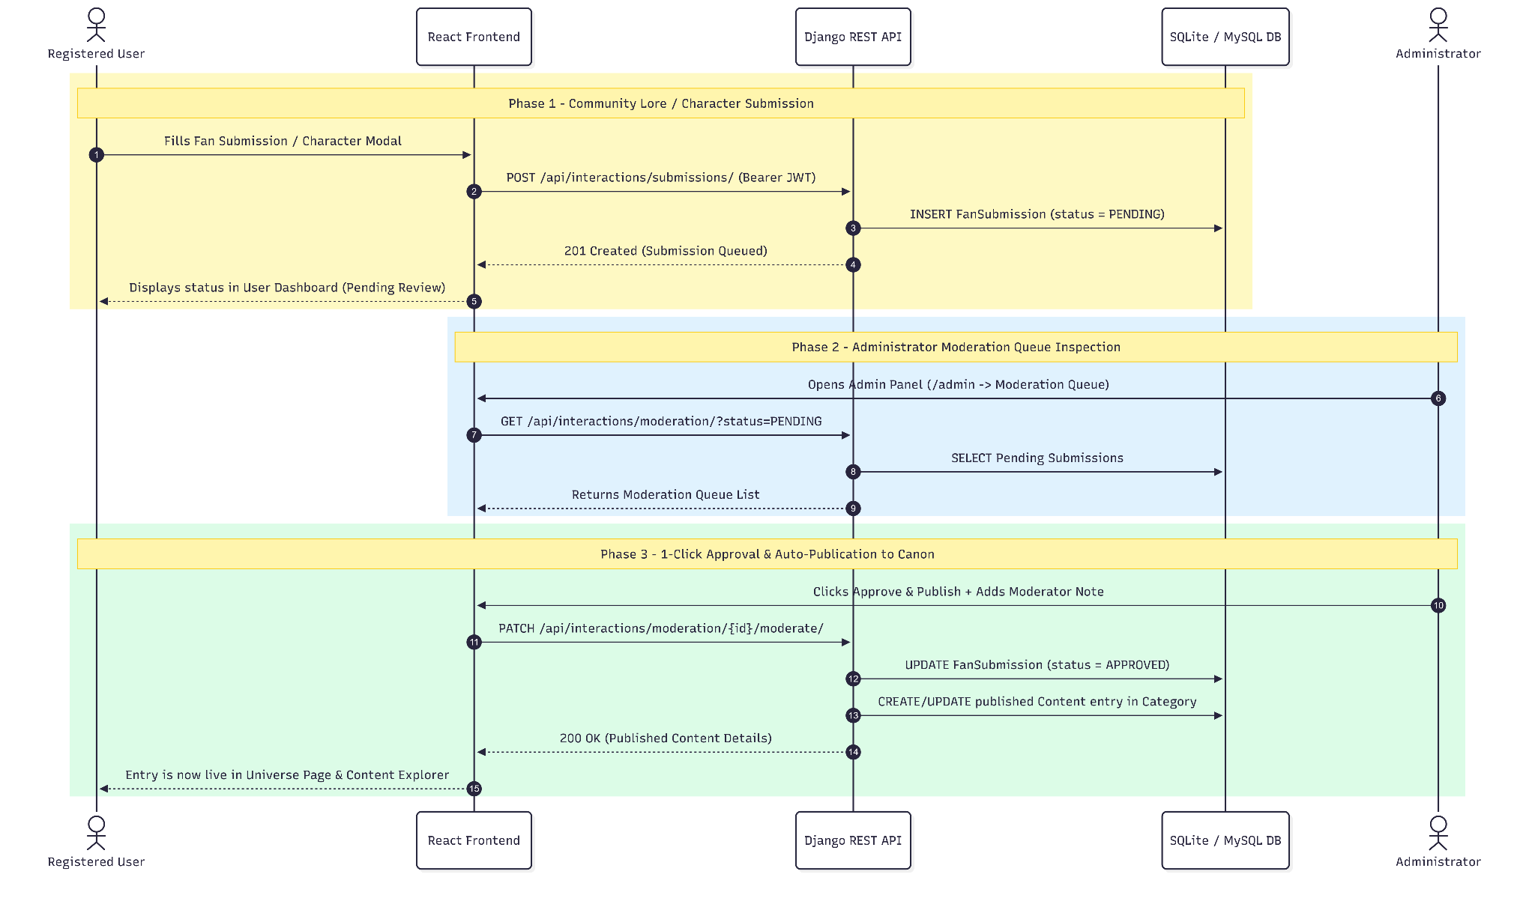

3.4.2 State Diagram: Moderation & Feedback Ticket Lifecycles
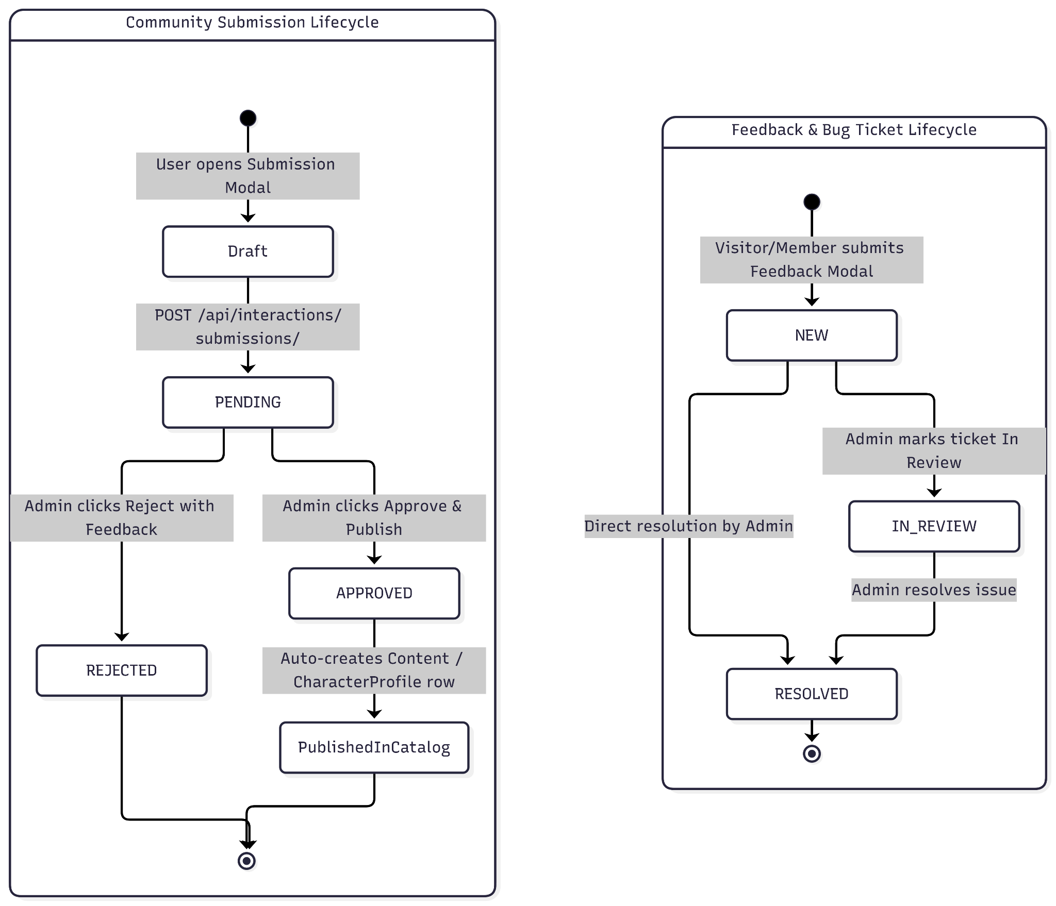

4. Database Design, Schema Diagrams & Data Dictionary
4.1 Color-Coded Database Domain & Foreign-Key Architecture
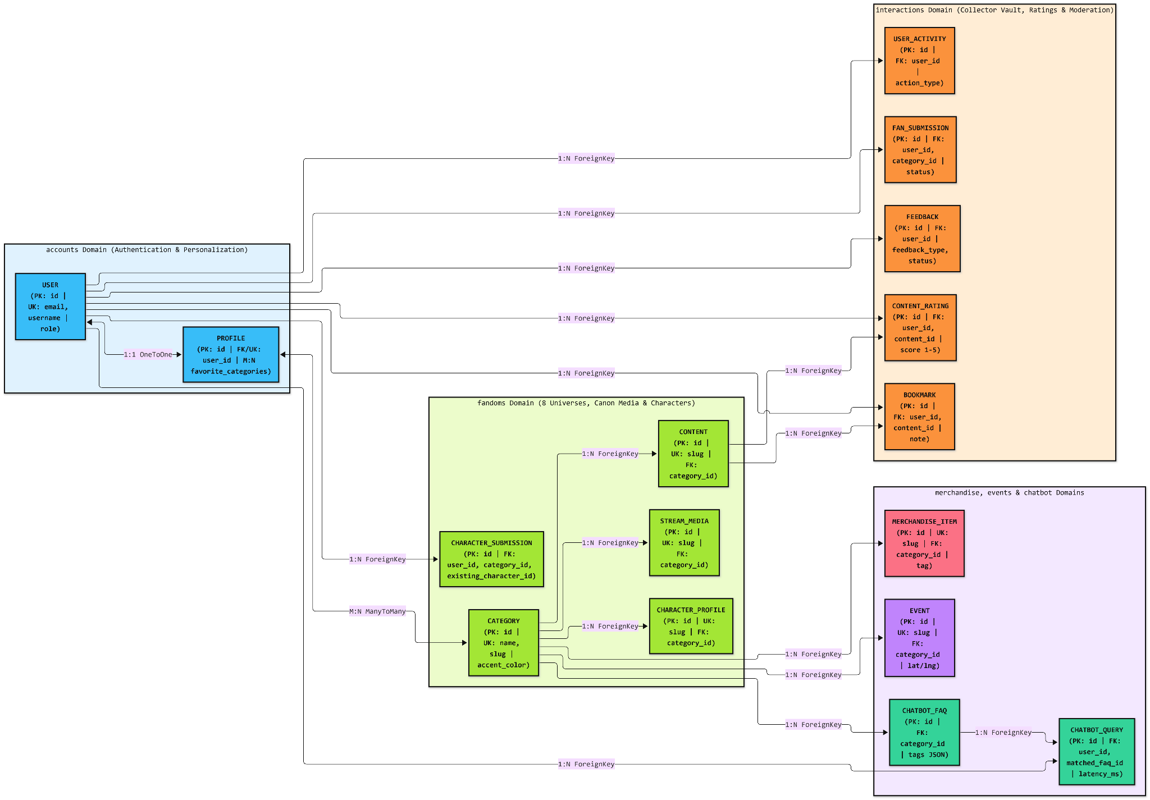

4.2 Relational Database Schema
4.2.1 User Management & Authentication

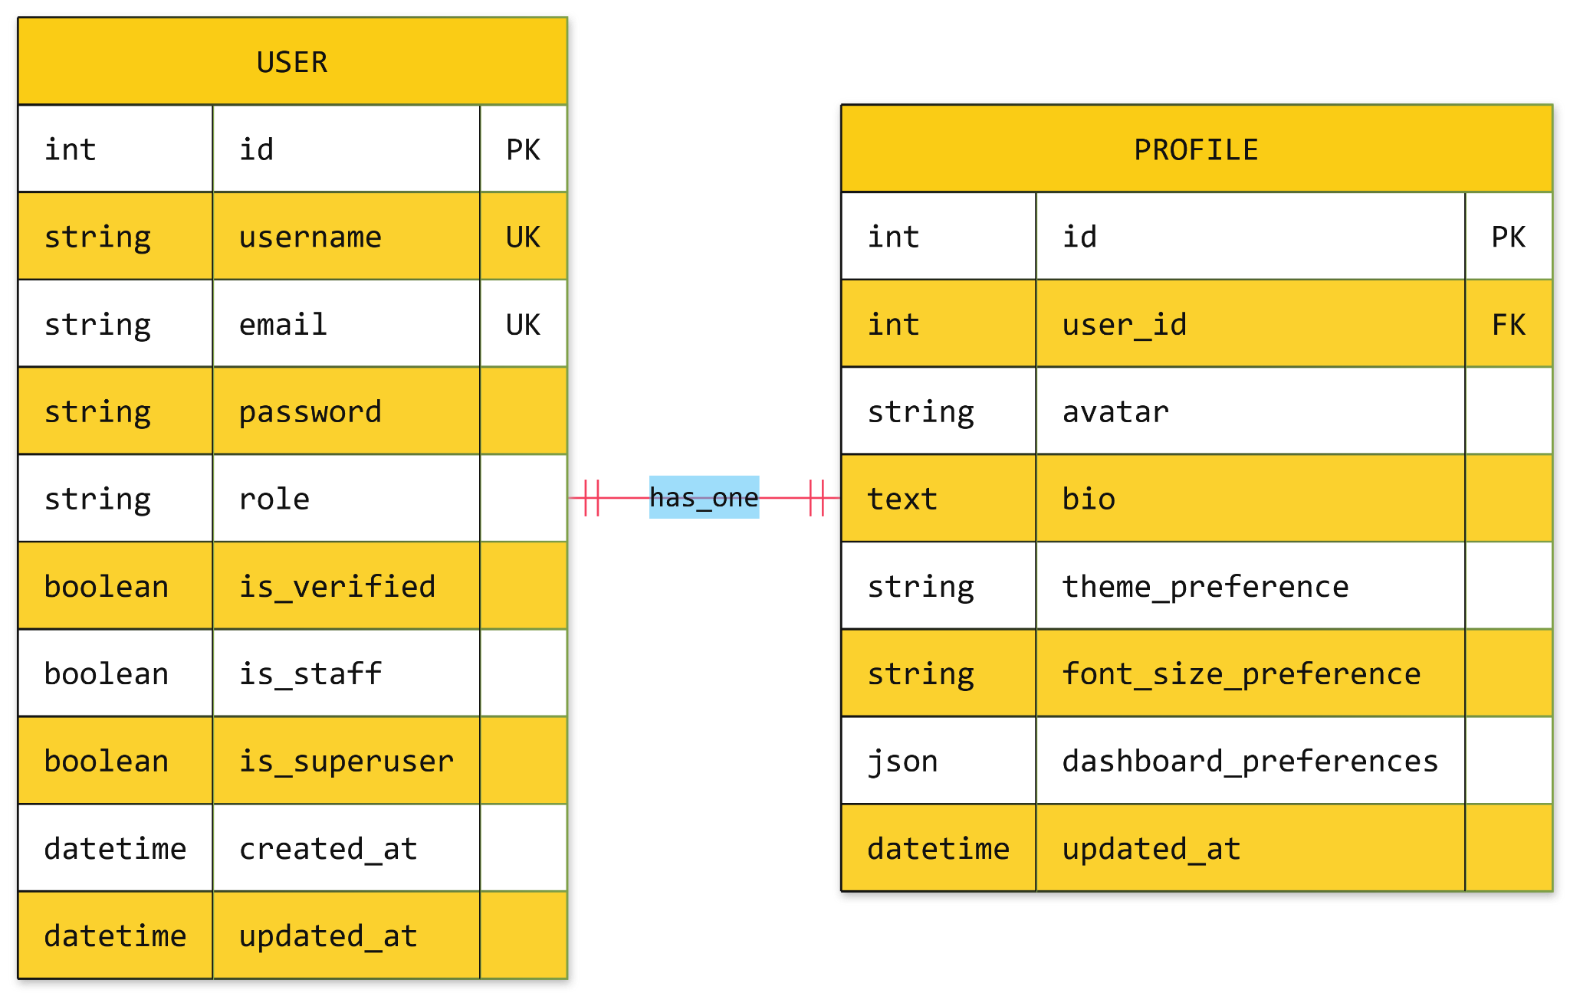

4.2.2 Content Management System
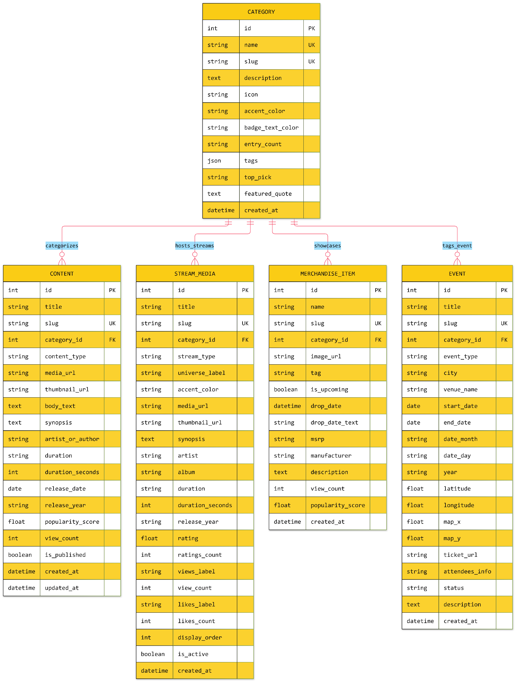
4.2.3 Character & Lore Management
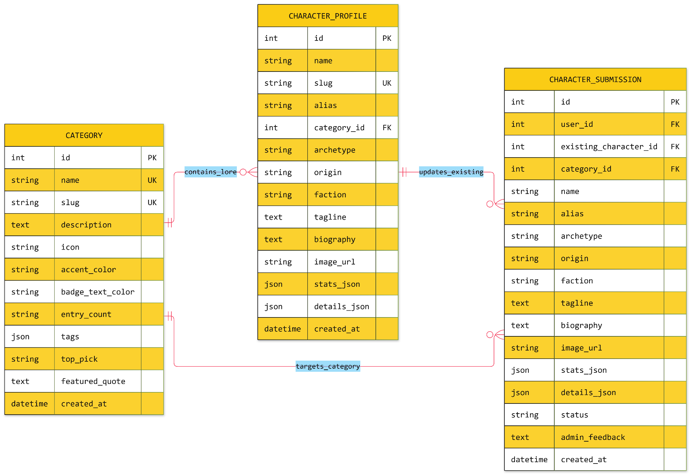

4.2.4 User Interactions & Engagement
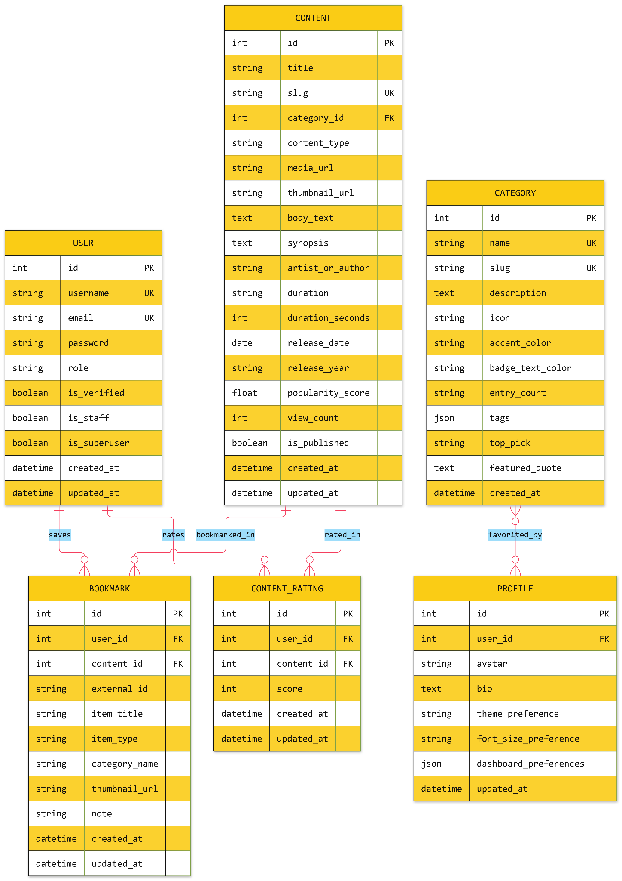
4.2.5 Community Submissions
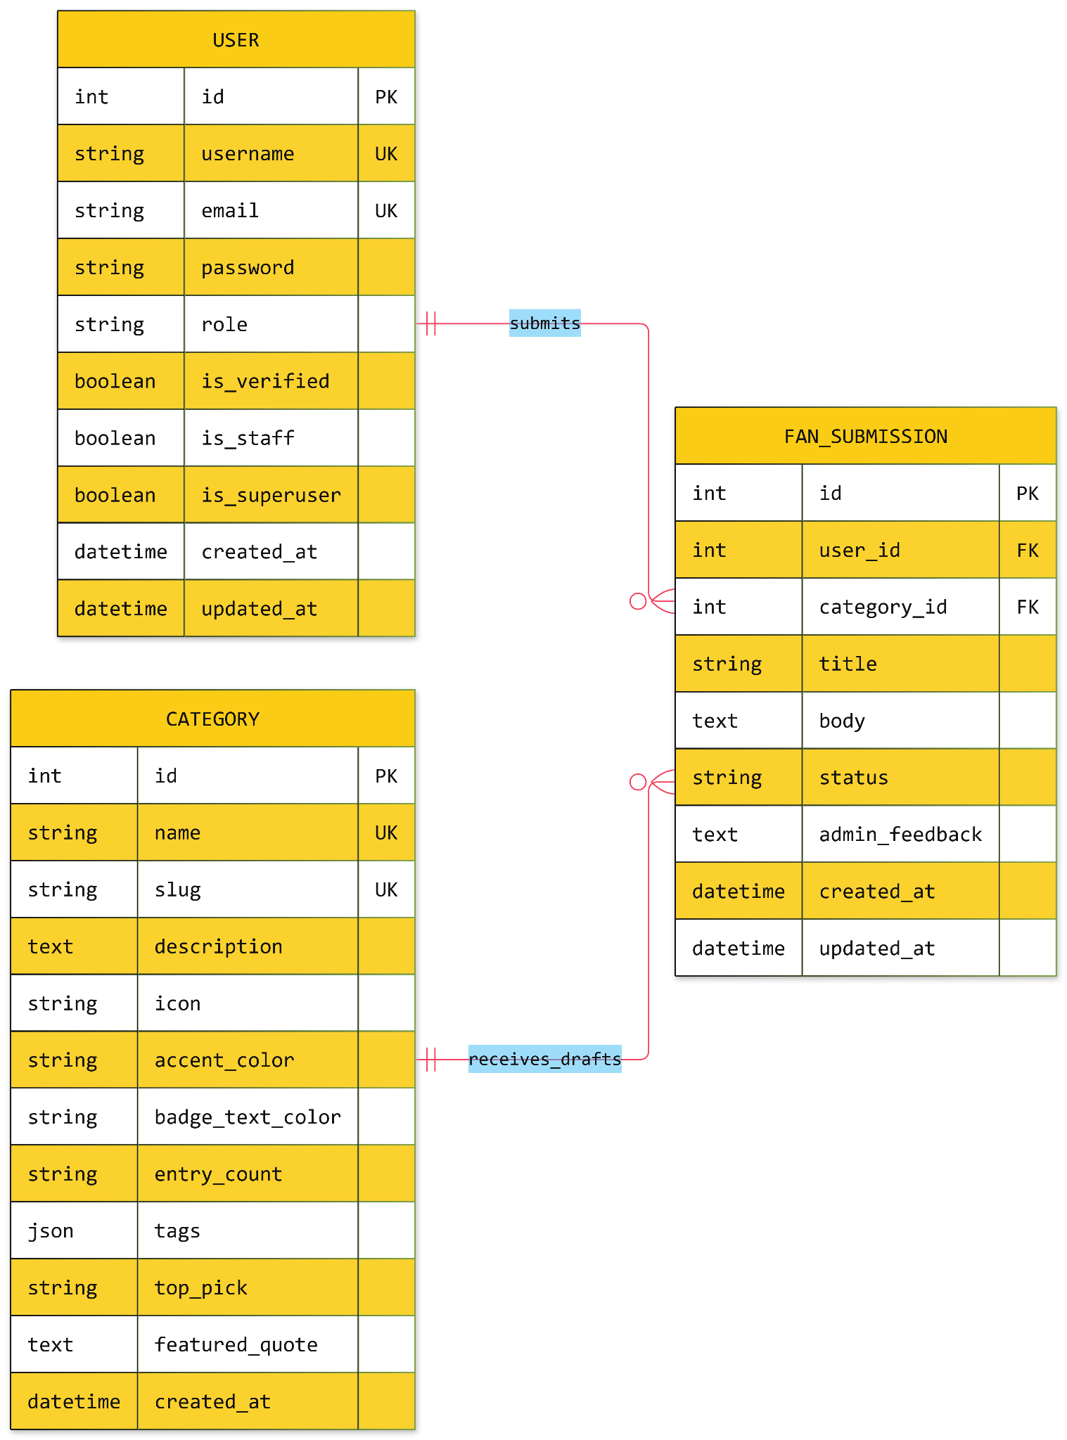

4.2.6 Chatbot System
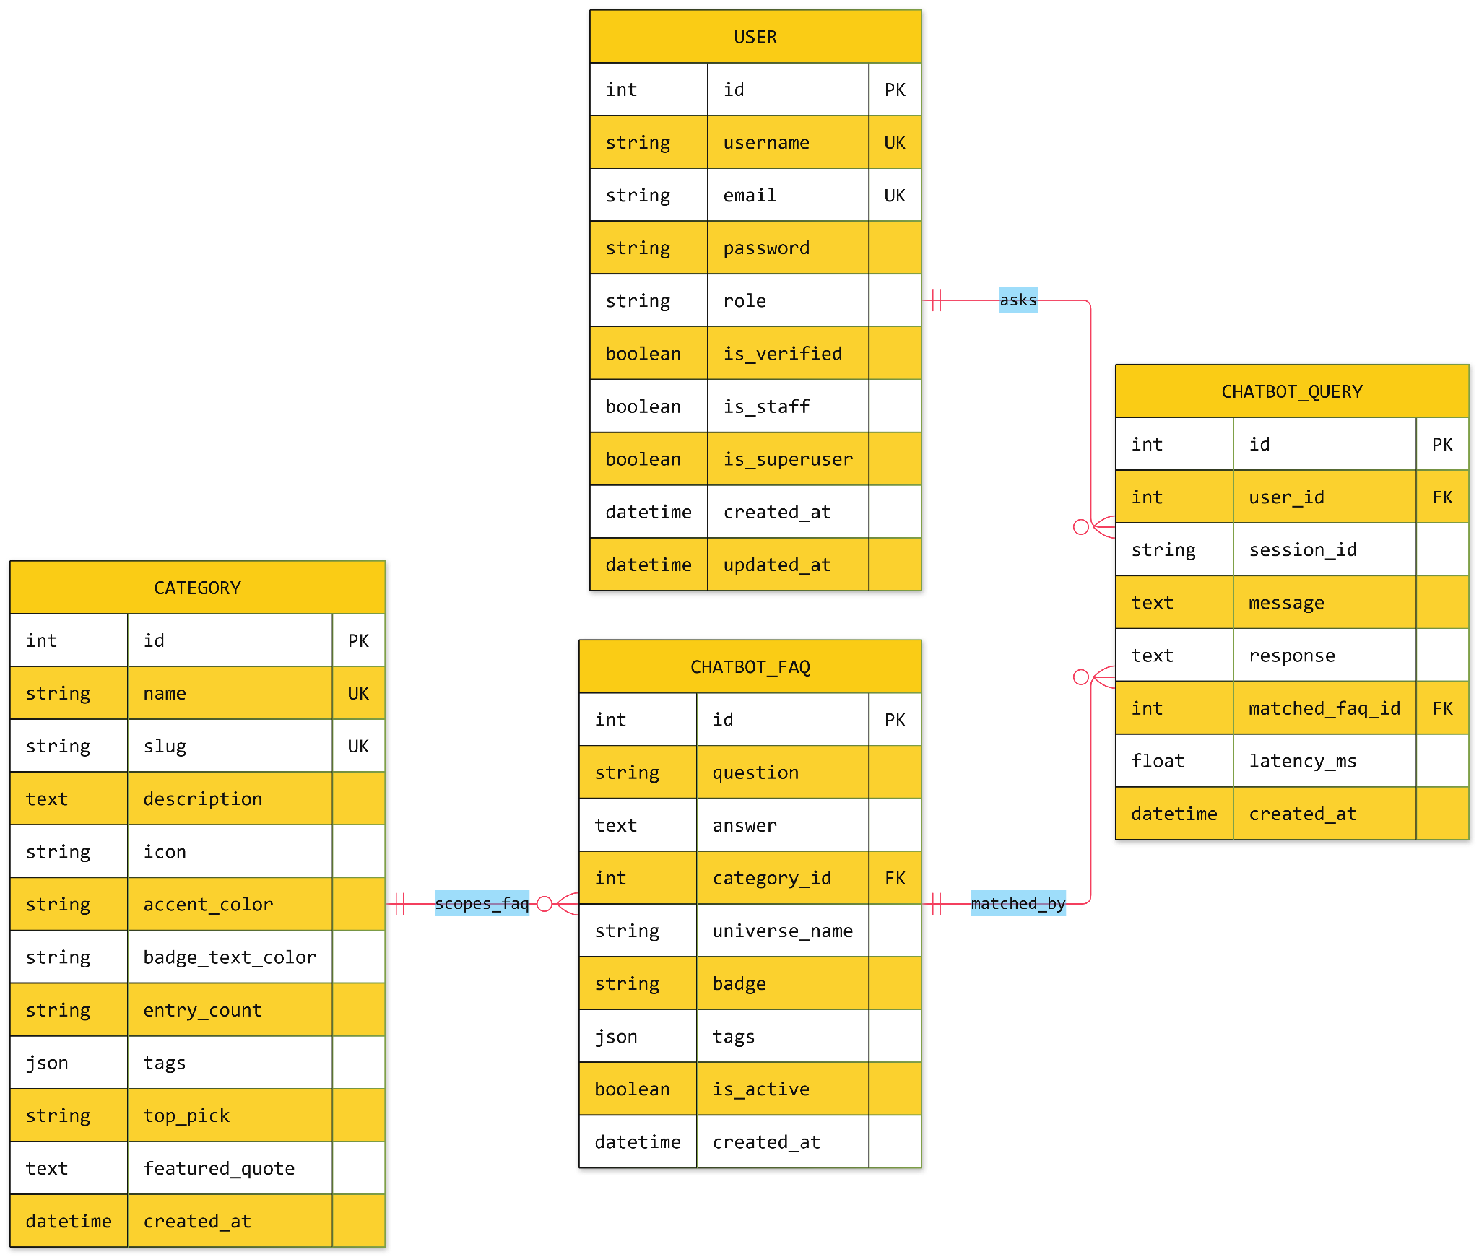

4.2.7 Feedback and Activity Tracking
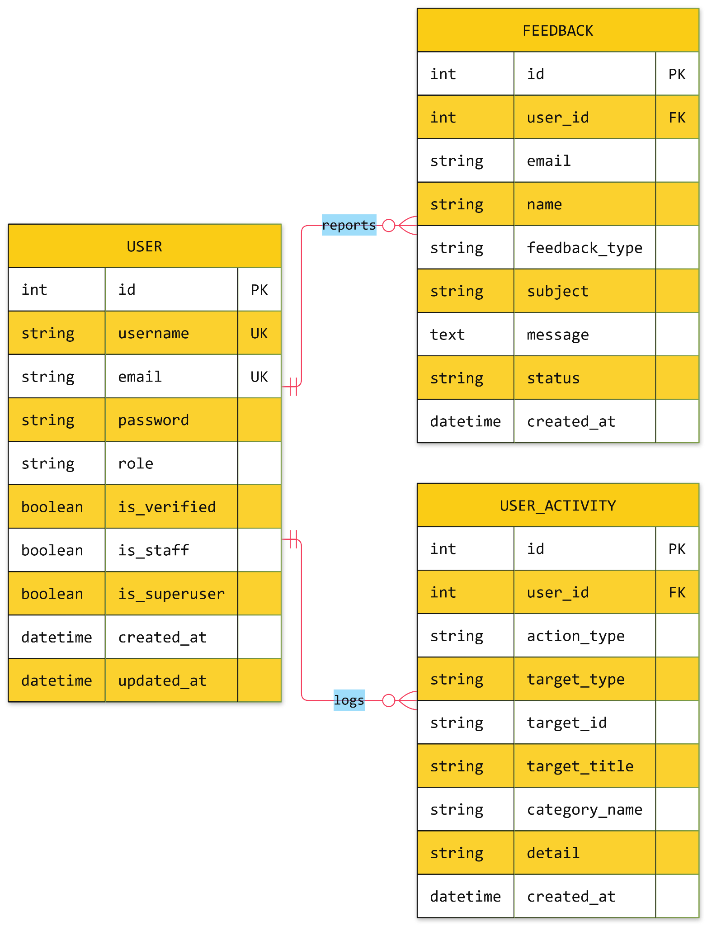

4.3 Complete Data Dictionary (All 15 Database Tables)
Table 1: accounts_user (User)
Stores authentication credentials and system-wide role permissions. Uses email as the primary login identifier (USERNAME_FIELD = 'email').
Column Name | Data Type | Constraints | Description
id | BigAutoField | PK, Auto-Increment | Unique user primary key
username | CharField(150) | UNIQUE, NOT NULL | Display handle (e.g., cyber_otaku, admin_fanhub)
email | EmailField(254) | UNIQUE, NOT NULL | Primary login email address
password | CharField(128) | NOT NULL | PBKDF2-SHA256 hashed password string
role | CharField(20) | INDEX, Default 'MEMBER' | Enum: 'VISITOR', 'MEMBER', 'ADMIN'
is_verified | BooleanField | Default False | Email verification status flag
is_staff | BooleanField | Default False | Grants access to Django admin site
is_superuser | BooleanField | Default False | Grants all permissions implicitly
created_at | DateTimeField | auto_now_add=True | Account registration timestamp
updated_at | DateTimeField | auto_now=True | Last account modification timestamp
Table 2: accounts_profile (Profile)
One-to-one extension of User created automatically via Django's post_save signal.
Column Name | Data Type | Constraints | Description
id | BigAutoField | PK | Unique profile primary key
user_id | ForeignKey | UNIQUE, ON DELETE CASCADE | Reference to accounts_user.id
avatar | CharField(1000) | NULL, BLANK | Profile picture URL or preset avatar URI
bio | TextField(500) | BLANK | Personal collector manifesto / bio
favorite_categories | ManyToManyField | Bridge table to Category | User's selected favorite fandom universes
theme_preference | CharField(10) | Default 'LIGHT' | Enum: 'LIGHT', 'DARK', 'SYSTEM'
font_size_preference | CharField(10) | Default 'NORMAL' | Enum: 'NORMAL' (16px), 'LARGE' (18.5px)
dashboard_preferences | JSONField | Default {} | Stores widget visibility and layout density (comfortable / compact)
updated_at | DateTimeField | auto_now=True | Last profile update timestamp
Table 3: fandoms_category (Category)
Stores the 8 mandatory fandom universes and their visual branding tokens.
Column Name | Data Type | Constraints | Description
id | BigAutoField | PK | Category primary key
name | CharField(100) | UNIQUE, NOT NULL | Display name (e.g., Anime, Gaming, K-Pop)
slug | SlugField(100) | UNIQUE, INDEX | URL-safe identifier (e.g., anime, movies-tv)
description | TextField | BLANK | Category overview blurb
icon | CharField(50) | Default 'Tv' | Lucide React icon identifier
accent_color | CharField(20) | Default '#38BDF8' | Hex color code for Neo-Brutalist accents
badge_text_color | CharField(20) | Default 'text-black' | Tailwind contrast class for category badges
entry_count | CharField(50) | Default '0+ Entries' | Display counter label (e.g., '240+ Entries')
tags | JSONField | Default [] | Array of sub-genre strings
top_pick | CharField(255) | BLANK | Featured spotlight title for this category
featured_quote | TextField | BLANK | Thematic quote displayed on the Universe Portal
created_at | DateTimeField | auto_now_add=True | Creation timestamp
Table 4: fandoms_content (Content)
Polymorphic media entity storing articles, video trailers, audio tracks, and visual showcases.
Column Name | Data Type | Constraints | Description
id | BigAutoField | PK | Content primary key
title | CharField(255) | INDEX, NOT NULL | Entry headline
slug | SlugField(255) | UNIQUE, INDEX | URL-safe slug
category_id | ForeignKey | INDEX, ON DELETE CASCADE | Reference to fandoms_category.id
content_type | CharField(20) | INDEX, Default 'ARTICLE' | Enum: 'ARTICLE', 'VIDEO', 'AUDIO', 'IMAGE'
media_url | URLField(1000) | NULL, BLANK | YouTube / streaming URL for video or audio items
thumbnail_url | URLField(1000) | NULL, BLANK | High-resolution cover image URL
body_text | TextField | BLANK | Full multi-paragraph article/essay body
synopsis | TextField | BLANK | Executive summary / card blurb
artist_or_author | CharField(255) | BLANK | Creator, studio, or editorial author name
duration | CharField(50) | BLANK | Read time or runtime (e.g., '7 min read', '02:45')
duration_seconds | PositiveIntegerField | Default 0 | Duration in seconds
release_year | CharField(100) | BLANK | Release year label (e.g., '2026', '2025')
popularity_score | FloatField | INDEX, Default 0.0 | Popularity metric used for sorting
view_count | PositiveIntegerField | Default 0 | Total view counter
is_published | BooleanField | INDEX, Default True | Visibility flag in public endpoints
created_at | DateTimeField | INDEX, auto_now_add=True | Publication timestamp
Table 5: fandoms_streammedia (StreamMedia)
Powers the Stream & Discover Audiovisual Vault with computed youtube_video_id and embed_url properties.
Column Name | Data Type | Constraints | Description
id | BigAutoField | PK | Stream item primary key
title | CharField(255) | INDEX, NOT NULL | Trailer or audio track title
slug | SlugField(255) | UNIQUE, INDEX | Unique stream slug
category_id | ForeignKey | INDEX, ON DELETE CASCADE | Reference to fandoms_category.id
stream_type | CharField(20) | INDEX, Default 'TRAILER' | Enum: 'TRAILER', 'AUDIO'
media_url | URLField(1000) | NOT NULL | YouTube watch/share link
thumbnail_url | URLField(1000) | BLANK | Cover art or video poster URL
artist / album | CharField(255) | BLANK | Studio, performer, or album metadata
duration / duration_seconds | CharField / Int | Default '02:45' / 165 | Formatted and numeric runtime
rating / ratings_count | FloatField / Int | Default 4.9 / 100 | Community star rating and vote count
view_count / likes_count | PositiveIntegerField | Default 0 | Engagement counters
is_active | BooleanField | INDEX, Default True | Active rotation flag
Table 6: fandoms_characterprofile (CharacterProfile) & Table 7: fandoms_charactersubmission (CharacterSubmission)
Stores canon character lore dossiers and user-submitted character proposals.
Column Name | Data Type | Constraints | Description
id | BigAutoField | PK | Primary key
name / slug | CharField / SlugField | INDEX / UNIQUE | Character name and URL-safe slug
alias | CharField(150) | BLANK | Epithet or title (e.g., 'Titan Slayer', 'Cyber Merc')
category_id | ForeignKey | INDEX, ON DELETE CASCADE | Universe category reference
archetype / origin / faction | CharField | BLANK | Lore classification, origin world, and allegiance
tagline / biography | TextField | BLANK | Signature quote and full character biography
image_url | URLField(1000) | BLANK | Character portrait URL
stats_json | JSONField | Default [] | Array of stat objects ({label, value, max, textValue})
details_json | JSONField | Default {} | Object containing firstAppearance, weapon, nemesis, bio
status (Submission only) | CharField(20) | Default 'PENDING' | Enum: 'PENDING', 'APPROVED', 'REJECTED'
Table 8: interactions_bookmark (Bookmark)
Links registered users to saved items across all content types with a personal collector note.
Column Name | Data Type | Constraints | Description
id | BigAutoField | PK | Bookmark primary key
user_id | ForeignKey | INDEX, ON DELETE CASCADE | Owner user reference
content_id | ForeignKey | NULL, BLANK, CASCADE | Optional FK to fandoms_content.id
external_id | CharField(150) | INDEX, BLANK | Slug/ID for characters, merch, or curated articles
item_title | CharField(255) | BLANK | Cached display title of the bookmarked item
item_type | CharField(30) | INDEX, Default 'ARTICLE' | Enum: 'ARTICLE', 'CHARACTER', 'VIDEO', 'AUDIO', 'MERCHANDISE'
category_name | CharField(100) | BLANK | Universe name label
thumbnail_url | URLField(1000) | NULL, BLANK | Item thumbnail image URL
note | CharField(500) | BLANK | Personal Collector Note (up to 500 characters)
created_at / updated_at | DateTimeField | Auto-managed | Timestamps
Table 9: interactions_contentrating (ContentRating)
Stores 1-to-5 star ratings per user per content item (UNIQUE(user_id, content_id)).
Column Name | Data Type | Constraints | Description
id | BigAutoField | PK | Rating primary key
user_id | ForeignKey | INDEX, ON DELETE CASCADE | Reference to accounts_user.id
content_id | ForeignKey | INDEX, ON DELETE CASCADE | Reference to fandoms_content.id
score | PositiveSmallInteger | MinValue(1), MaxValue(5) | Star rating between 1 and 5
Table 10: interactions_fansubmission (FanSubmission)
Holds user-submitted fan essays, lore theories, and cosplay build guides awaiting moderation.
Column Name | Data Type | Constraints | Description
id | BigAutoField | PK | Submission primary key
user_id | ForeignKey | INDEX, ON DELETE CASCADE | Author user reference
category_id | ForeignKey | INDEX, ON DELETE CASCADE | Target fandom universe
title / body | CharField / TextField | NOT NULL | Submission title and markdown/plain-text body
status | CharField(20) | INDEX, Default 'PENDING' | Enum: 'PENDING', 'APPROVED', 'REJECTED'
admin_feedback | TextField | BLANK | Moderator review notes or rejection reason
Table 11: interactions_feedback (Feedback) & Table 12: interactions_useractivity (UserActivity)
Stores support/bug tickets (BUG, SUGGESTION, INQUIRY with status NEW, IN_REVIEW, RESOLVED) and the user's chronological activity stream (VIEW, BOOKMARK, NOTE, RATING, SUBMISSION, CHATBOT, FILTER, PROFILE).
Table 13: merchandise_merchandiseitem (MerchandiseItem)
Non-transactional collector showcase table.
Column Name | Data Type | Constraints | Description
id / slug | BigAutoField / Slug | PK / UNIQUE | Merchandise primary key and slug
name | CharField(255) | INDEX, NOT NULL | Collectible name
category_id | ForeignKey | INDEX, ON DELETE CASCADE | Reference to fandoms_category.id
tag | CharField(30) | INDEX | Enum: 'LIMITED_EDITION', 'PRE_ORDER', 'COLLECTIBLE', 'OFFICIAL_LICENSED'
is_upcoming | BooleanField | INDEX, Default False | Whether item appears on the Upcoming Countdown Radar
drop_date_text | CharField(150) | BLANK | Human-readable release window
msrp / manufacturer | CharField | BLANK | Reference MSRP preview string and studio name
view_count / popularity_score | Int / Float | INDEX | Popularity telemetry counters
Table 14: events_event (Event)
Global convention schedule with physical and stylized radar coordinates.
Column Name | Data Type | Constraints | Description
id / slug | BigAutoField / Slug | PK / UNIQUE | Event primary key and slug
title / city / venue_name | CharField | INDEX | Event name, host city, and convention center
category_id | ForeignKey | INDEX, ON DELETE CASCADE | Primary fandom category
start_date / end_date | DateField | INDEX | Start and end calendar dates
latitude / longitude | FloatField | INDEX | GPS coordinates for Haversine distance calculation
map_x / map_y | FloatField | Default 50.0 | Percentage coordinates (0–100) on the stylized world map
ticket_url / status | URLField / CharField | BLANK | Official registration URL and status badge
Table 15: chatbot_chatbotfaq (ChatbotFAQ) & chatbot_chatbotquery (ChatbotQuery)
Stores deterministic Q&A pairs (question, answer, universe_name, badge, tags JSON, is_active) and the query audit log (user_id, session_id, message, response, matched_faq_id, latency_ms).

5. Comprehensive Feature Breakdown & Screenshot Placeholders
5.1 Sticky Navigation Header, Accessibility Controls & Dynamic Breadcrumbs
- Components: Header.jsx, Breadcrumbs.jsx
- Capabilities: section jump links, zero-flash Dark Mode Toggle, root Font-Size Scaler (A- / A+), role-aware My Dashboard / Admin Panel badges, and a dynamic Breadcrumbs bar (Home > Universe > Article).

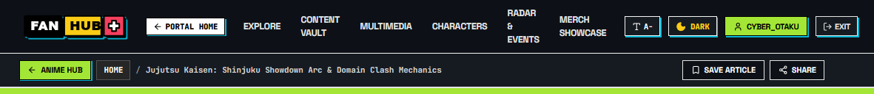
Header, Dark Mode & Breadcrumbs

5.2 Hero Command Center & 8-Universe Category Matrix
- Components: HeroSection.jsx, UniverseMatrix.jsx, UniversePage.jsx
- Capabilities: Interactive spotlight preview card, quick-filter universe pills, 8 color-coded fandom silo cards, and dedicated /universe/:slug portals with sub-genre filtering and universe-specific media.
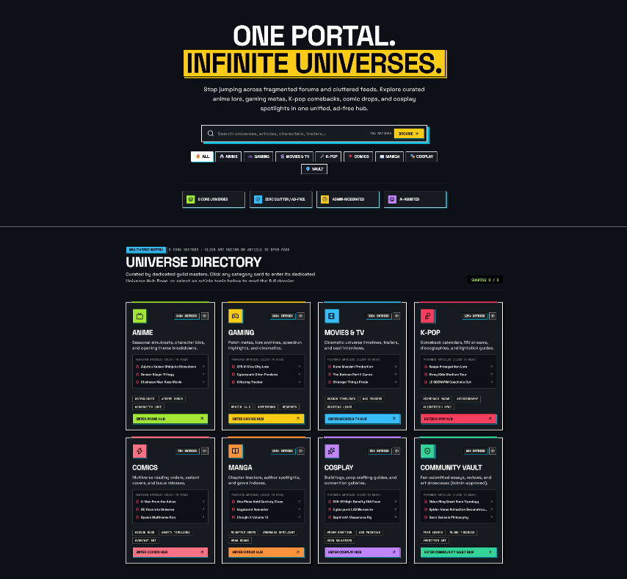
Hero Command Center & 8-Universe Matrix
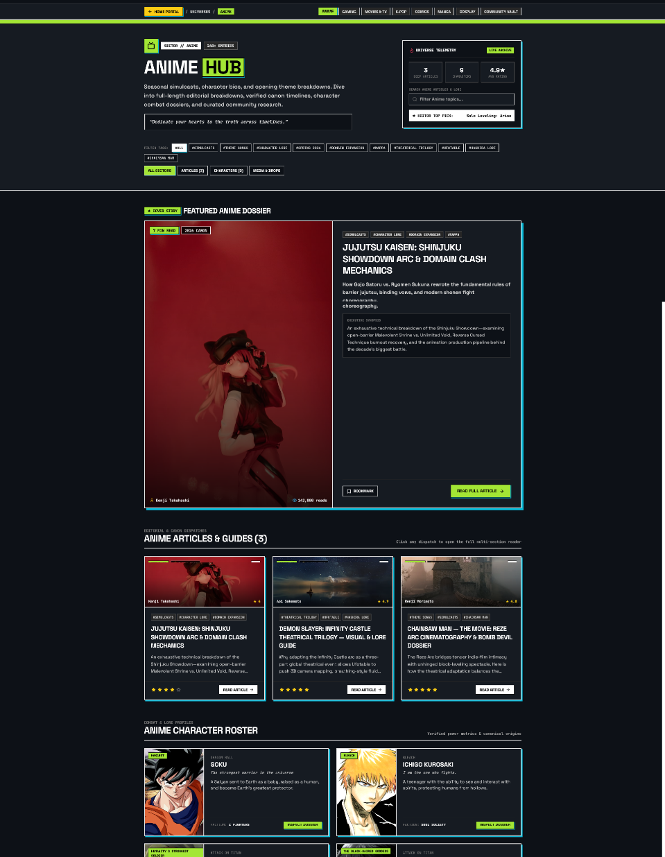
Dedicated Universe Portal (/universe/anime)

5.3 Multi-Level Fandom Content Explorer & Rich-Text Article Reader
- Components: ContentExplorer.jsx, ArticlePage.jsx, ArticleReader.jsx
- Capabilities: 6-level filter sidebar (Keyword, Media Type, Universe, Genre Tag, Release Year, Popularity Threshold), 3-mode sorting (Most Popular, Latest, A-Z), real-time reading progress bar, 1–5 star rating widget, and inline personal collector note editor.
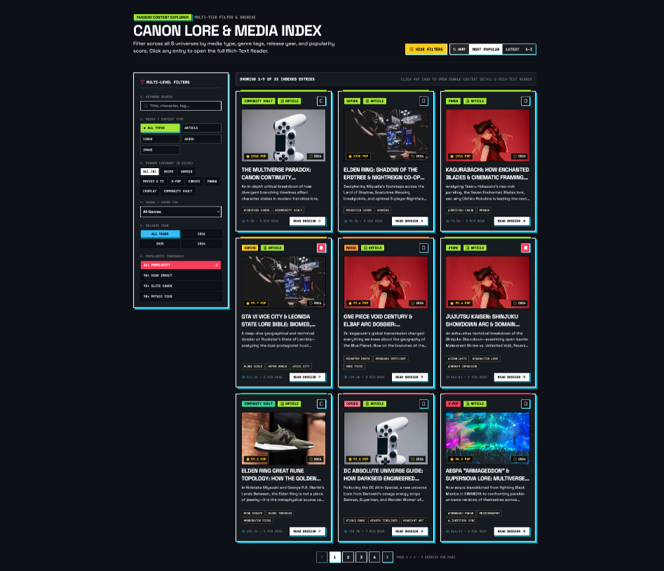
Multi-Level Content Explorer & Filter Sidebar
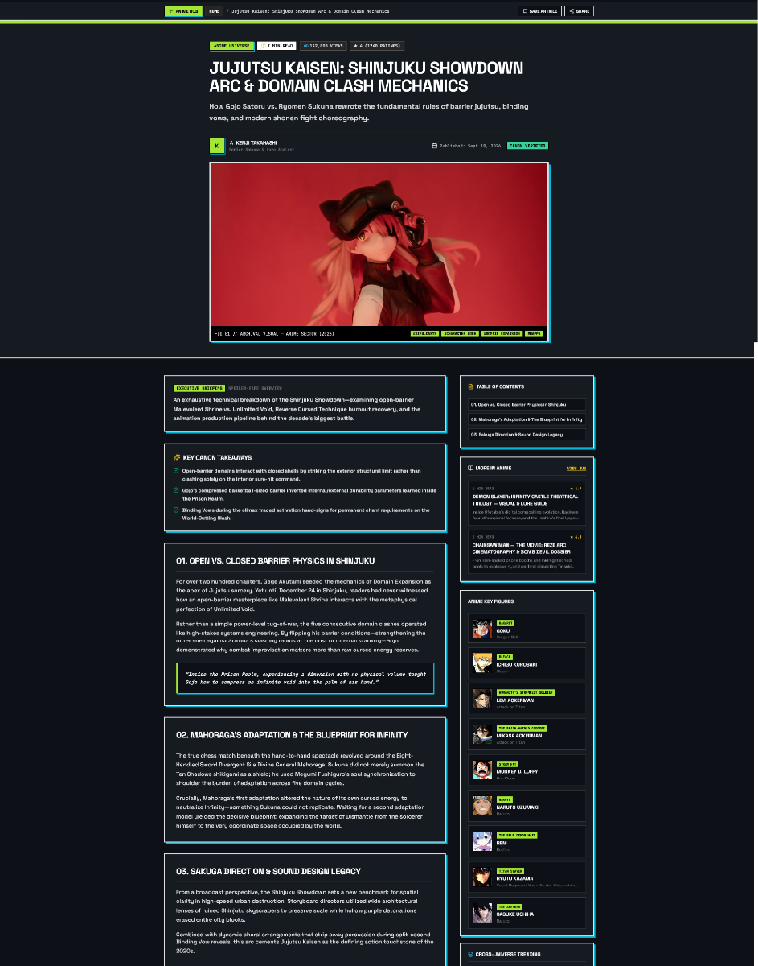
Rich-Text Article Reader & Collector Note Editor
5.4 Stream & Discover Audiovisual Vault
- Component: MultimediaCenter.jsx
- Capabilities: 4K Video Trailer player with Theater Mode, custom scrubber/mute/fullscreen transport bar, star ratings, and an OST/K-Pop Audio Streamer with a 32-bar animated waveform visualizer and community like counter.
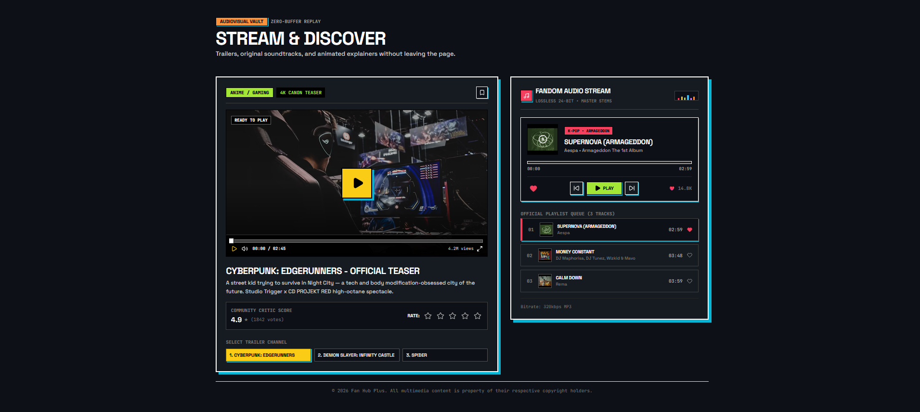
Stream & Discover 4K Video & Audio Waveform Deck

5.5 Character Lore Roster & 2-Fighter Versus Stat Comparison Arena
- Component: CharacterArchive.jsx
- Capabilities: Character cards across all 8 universes, expandable Lore Dossier modal, community character submission trigger, and an interactive 2-Fighter Versus Stat Comparison Arena comparing Agility, Combat Power, Strategic IQ, and Projected Winner.
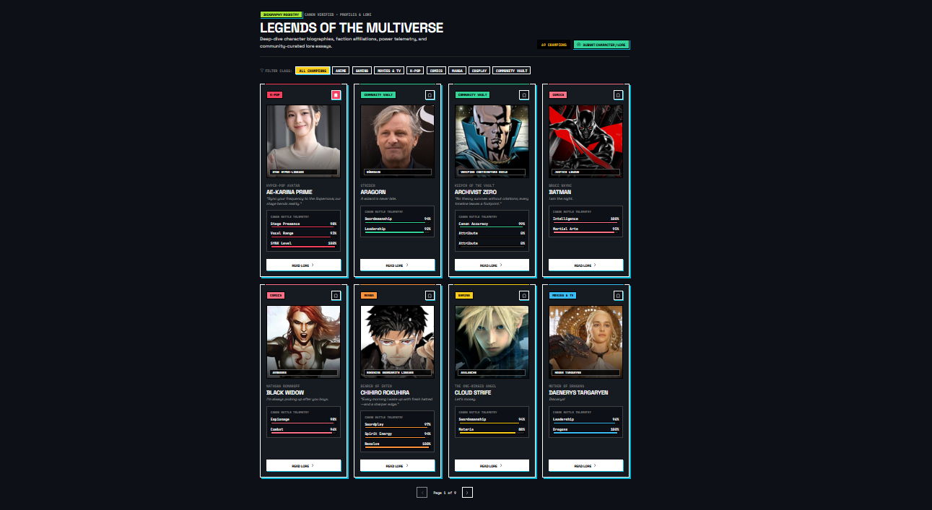
Character Lore Roster & 2-Fighter Versus Arena

5.6 Collector's Merchandise Vault
- Components: MerchRadar.jsx, ResourceLibrary.jsx
- Capabilities: 24+ non-transactional merchandise drops across all 8 universes, multi-image gallery switcher, status tag filters (LIMITED_EDITION, PRE_ORDER, COLLECTIBLE, OFFICIAL_LICENSED) and popularity click telemetry.
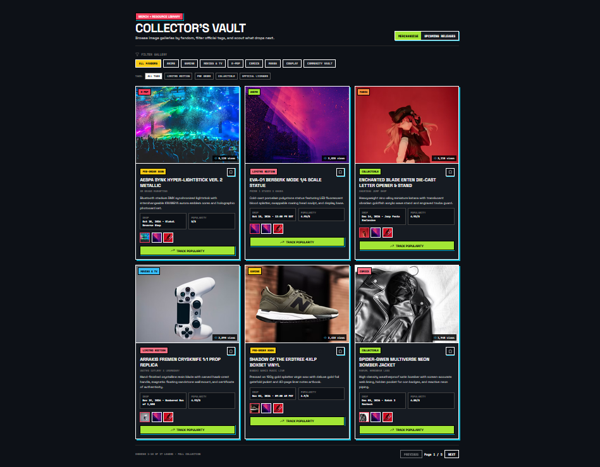Collector's Merchandise Vault
5.7 Global Convention Radar, Interactive World Map & .ics Calendar Export
- Component: ConventionRadar.jsx
- Capabilities: Interactive world map with pulsing city pins (Tokyo, Los Angeles, London, Lagos), Haversine GPS "Near Me" distance filtering, and 1-click .ics calendar file generation.
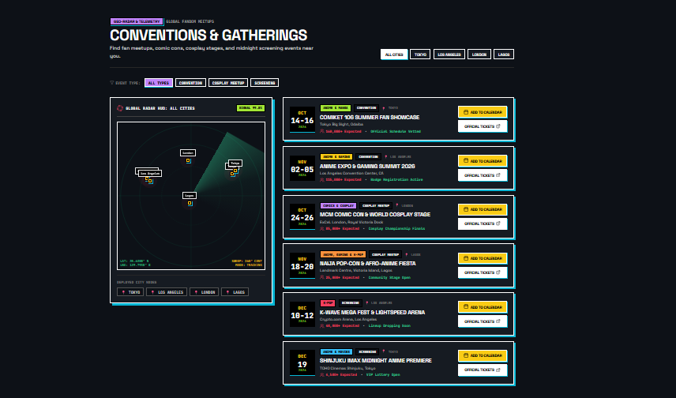
Global Convention Radar & Interactive Map

5.8 FandomBot AI Lore Assistant
- Component: FandomBot.jsx
- Capabilities: Slide-over chat drawer, 1-click starter prompts, clickable deep-link recommendation cards, thumbs up/down response ratings, and session history clearing.
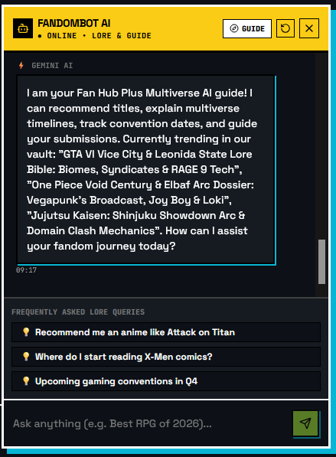
FandomBot AI Lore Assistant Drawer

5.9 Personalized User Dashboard (/dashboard) & Admin Command Center (/admin)
- Components: UserDashboard.jsx, AdminDashboard.jsx
- Capabilities:
- User Dashboard (/dashboard): Personalized greeting, KPI strip, Bookmarked Items Vault with inline Personal Collector Notes, Favorite Fandoms selector, Display Preferences (comfortable/compact, widget toggles, theme/font sync), Recent Activity Stream, and Submissions Tracker.
- Admin Command Center (/admin): Platform KPI analytics, 1-click Moderation Queue for Fan Submissions & Character Profiles, full CRUD tables for Categories, Content, Characters, Merchandise, Events, and Chatbot FAQs, plus Feedback/Bug ticket resolution.
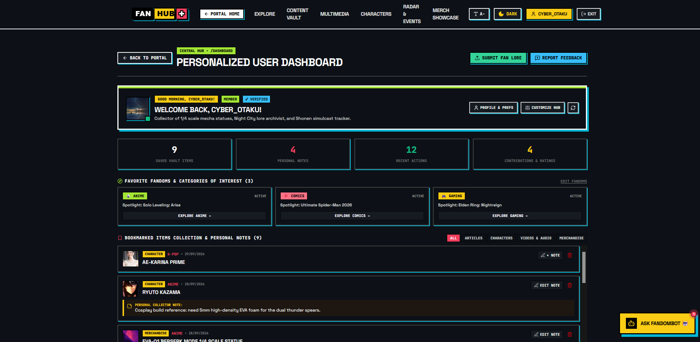
Personalized User Dashboard (/dashboard)
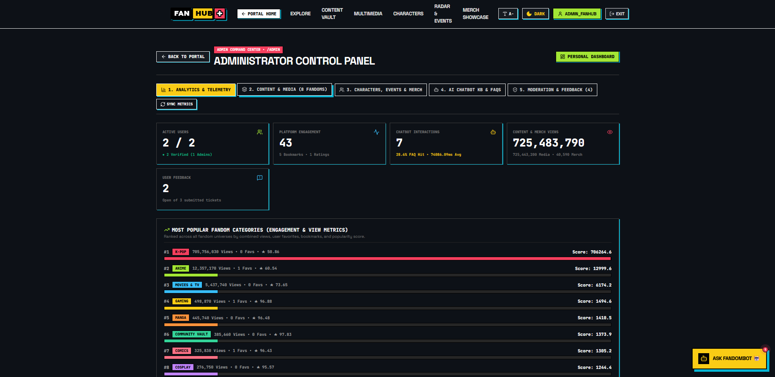
Administrator Command Center (/admin)

6. Test Data Used in the Project & Verification Matrix
All test data is automatically populated into SQLite (db.sqlite3) via python manage.py seed_data (seed_data.py) or into MySQL via seed_data.sql.
6.1 Seeded Content & Multimedia Records (Content & StreamMedia)
Slug | Title | Universe | Type | Author / Artist | Duration | Popularity / Views
jujutsu-kaisen-shinjuku-showdown | Jujutsu Kaisen: Shinjuku Showdown Arc & Domain Clash Mechanics | Anime | ARTICLE | Kenji Takahashi | 7 min read | 4.95 / 84,200
elden-ring-shadow-erdtree-lore | Elden Ring: Shadow of the Erdtree & Nightreign Co-Op Meta Guide | Gaming | ARTICLE | Valkyrie_Builds | 8 min read | 4.95 / 96,300
dune-messiah-production-diary | Dune: Messiah & The Golden Path — Villeneuve's Tragic Space Opera | Movies & TV | ARTICLE | Elena Vance | 7 min read | 4.90 / 71,800
aespa-armageddon-world-tour-recap | aespa Armageddon & KWANGYA Lore: The Metallic Hyper-Pop Blueprint | K-Pop | ARTICLE | Soo-Jin Park | 6 min read | 4.95 / 112,400
x-men-from-the-ashes-reading-order | X-Men: From the Ashes & Post-Krakoa Reading Order Matrix | Comics | ARTICLE | Marcus Sterling | 8 min read | 4.85 / 49,800
kagurabachi-enchanted-blades-analysis | Kagurabachi: How Enchanted Blades & Cinematic Framing Ignited Jump | Manga | ARTICLE | Daichi Sato | 6 min read | 4.90 / 73,500
eva-01-led-foam-armor-blueprint | EVA-01 High-Density Foam Armor & Addressable LED Wiring Blueprint | Cosplay | ARTICLE | Lyra Solaris Workshop | 10 min read | 4.95 / 44,900
multiverse-paradox-essay | The Multiverse Paradox: Canon Continuity Deconstruction | Community Vault | ARTICLE | Fan Creator: cyber_otaku | 8 min read | 4.80 / 9,200
cyberpunk-edgerunners | Cyberpunk: Edgerunners - Official Teaser | Anime | VIDEO / TRAILER | Studio Trigger & CDPR | 02:45 | 4.90 / 4,200,000
infinity-castle | Demon Slayer: Infinity Castle - Cinematic Teaser | Anime | VIDEO / TRAILER | ufotable | 03:12 | 5.00 / 7,800,000
spider-multiverse | Spider-Man: Beyond The Spider-Verse Sneak Peek | Movies & TV | VIDEO / TRAILER | Sony Pictures Animation | 02:18 | 4.80 / 5,100,000
kpop-supernova | Supernova (Armageddon) | K-Pop | AUDIO | Aespa | 02:59 | 4.90 / 14.8K Likes
money-constant | MONEY CONSTANT | K-Pop | AUDIO | DJ Maphorisa, DJ Tunez, Wizkid & Mavo | 03:48 | 4.95 / 84.5K Likes
calm-down | Calm Down | K-Pop | AUDIO | Rema | 03:59 | 5.00 / 5.2M Likes
6.2 Seeded Character Lore Profiles (CharacterProfile All 8 Universes)
Slug | Name | Alias | Universe | Faction | Primary Weapon / Relic
ryuto-kazama | Ryuto Kazama | Titan Slayer | Anime | Survey Scout Vanguard Neo | Dual Thunder Spears & Carbon Blade Rigs
valkyrie-v09 | Valkyrie V-09 | Cyber Merc | Gaming | Afterlife Independent Mercs | Thermal Monowire & Arasaka Prototype MK-7
paul-muaddib | Kwisatz Navigator | Sovereign of Arrakis | Movies & TV | Fremen Fedaykin Council | Crysknife of Maker Tooth & Weirding Module
nova-kwangya | AE-Karina Prime | Hyper-Pop Avatar | K-Pop | SYNK Hyper-Lineage | Sonic Lightstick Frequency & Rocket Puncher
shadow-raven | Shadow Raven | The Nocturnal Vigilante | Comics | Midnight Syndicate | Obsidian Batarangs & Dark Energy Cloak
kuro-kenshin | Chihiro Rokuhira | Bearer of Enten | Manga | Rokuhira Swordsmith Lineage | Enchanted Blade: Enten (Kuro, Aka, Nishiki)
lyra-solaris | Lyra Solaris | Celestial Weaver | Cosplay | Astral Order of Luminaries | Prism Leyline Staff with Luminescent Core
archivist-zero | Archivist Zero | Keeper of the Vault | Community Vault | Verified Contributors Guild | Cross-Universe Citation Matrix
6.3 Seeded Global Conventions (Event)
Slug | Event Title | City | Venue | Dates | GPS (lat, lng) | Map (x%, y%)
event-tokyo | Comiket 106 Summer Fan Showcase | Tokyo | Tokyo Big Sight, Odaiba | Aug 14–16, 2026 | 35.6300, 139.7930 | 78.0, 35.0
event-la-anime | Anime Expo & Gaming Summit 2026 | Los Angeles | LA Convention Center, CA | Jul 02–05, 2026 | 34.0407, -118.2699 | 20.0, 38.0
event-london | MCM Comic Con & World Cosplay Stage | London | ExCeL London, Royal Dock | Oct 24–26, 2026 | 51.5074, 0.0278 | 48.0, 26.0
event-lagos | Naija Pop-Con & Afro-Anime Fiesta | Lagos | Landmark Centre, VI Lagos | Nov 18–20, 2026 | 6.4281, 3.4219 | 49.0, 55.0
event-la-kpop | K-Wave Mega Fest & Lightspeed Arena | Los Angeles | Crypto.com Arena, LA | Dec 10–12, 2026 | 34.0430, -118.2673 | 22.0, 40.0
6.4 Seeded Bookmarks with Personal Collector Notes, Moderation Queue & Feedback Tickets
- Pre-Seeded Bookmarks for cyber_otaku (fan@fanhub.com):
- cyberpunk-edgerunners (VIDEO): "Rewatch frame-by-frame for Sandevistan color grading breakdown at 01:42."
- multiverse-paradox-essay (ARTICLE): "Reference Section 3 for my upcoming Secret Wars timeline diagram."
- ryuto-kazama (CHARACTER): "Cosplay build reference: need 5mm high-density EVA foam for the dual thunder spears."
- merch-eva (MERCHANDISE): "Pre-order opens Oct 15 at 12:00 PM EST set alarm 30 mins early!"
- Pre-Seeded Fan Submissions (FanSubmission):
- Neon Genesis Evangelion: The Instrumentality Timeline Paradox (Anime Status: PENDING)
- Elden Ring: Shadow of the Erdtree Miquella Motive Analysis (Gaming Status: PENDING)
- Spider-Man 2099 Monowire Prop 3D Build Log (Cosplay — Status: APPROVED)
- Pre-Seeded Feedback Tickets (Feedback):
- [BUG] 4K Trailer Player Fullscreen Shortcut on Safari (IN_REVIEW)
- [SUGGESTION] Add STL 3D Print File Attachment Support to Cosplay Guides (NEW)
- [INQUIRY] K-Wave Mega Fest Los Angeles Badge Pickup Hours (RESOLVED)
6.5 Functional Verification Matrix
Test ID | Module | Test Scenario | Input / Action | Expected Result | Status
TC-01 | Auth & RBAC | Login as Registered Member | fan@fanhub.com / MemberPass123! | Issues JWTs, unlocks /dashboard, hides /admin | PASS
TC-02 | Auth & RBAC | Login as Administrator | admin@fanhub.com / AdminPass123! | Issues JWTs, unlocks both /admin and /dashboard | PASS
TC-03 | Accessibility | Toggle Dark Mode & Font Scaler | Click Moon/Sun & A+ in Header | Toggles .dark class without flash & sets root 18.5px | PASS
TC-04 | Content Explorer | Multi-Level Filtering & Sorting | Select Anime + ARTICLE + Most Popular | Filters catalog in real time and sorts by popularity | PASS
TC-05 | Bookmarks & Notes | Save Bookmark & Edit Note | Click Bookmark icon -> Edit Note in /dashboard | Persists note via PATCH /api/interactions/bookmarks/note/ | PASS
TC-06 | Character Arena | 2-Fighter Versus Comparison | Select Ryuto Kazama vs Valkyrie V-09 | Renders comparative stat bars & calculates Arena Victor | PASS
TC-07 | Merch Vault | Filter Showcase & Track Click | Click Gaming filter + Track Popularity | Displays Gaming drops, increments live view counter | PASS
TC-08 | Convention Radar | Map Pin Selection & .ics Export | Click Tokyo pin -> Click Add to Calendar | Highlights Comiket 106 card & downloads .ics invite | PASS
TC-09 | FandomBot AI | Deterministic FAQ Query | Ask "Recommend me an anime like Attack on Titan" | Returns curated response (<15ms) with clickable cards | PASS
TC-10 | Admin Moderation | Approve Pending Fan Submission | Click Approve & Publish in /admin Queue | Updates status to APPROVED & creates live Content | PASS

7. Project Installation Instructions & Running the App Locally
Follow these step-by-step instructions to install, seed, and run Fan Hub Plus on your local machine.
7.1 Prerequisites
Ensure the following tools are installed on your system:
- Python: 3.11+ or 3.12+ (with pip and venv)
- Node.js: 18.0+ or 20.0+ (with npm)
- Git: For cloning the repository
7.2 Step 1: Clone the Repository
- git clone https://github.com/haleemakintayo/fanHubPlus.git
- Run the command: cd fanHubPlus
The repository contains two primary directories:
- fanHubPlus_backend/ — Django 5 + DRF REST API server & SQLite database (db.sqlite3)
- Fanhub_frontend/ — React 19 + Vite + Tailwind CSS v4 frontend client
7.3 Step 2: Backend Installation & Database Seeding (fanHubPlus_backend)
On Windows (PowerShell):
# 1. Navigate to the backend folder
cd fanHubPlus_backend
# 2. Create a Python virtual environment (if not already created)
python -m venv venv
# 3. Activate the virtual environment
.\venv\Scripts\activate
# 4. Install Python dependencies
pip install -r requirements.txt
# 5. Apply database migrations to SQLite (db.sqlite3)
python manage.py migrate
# 6. Seed all 8 universes, articles, trailers, characters, merchandise, events, FAQs & demo users
python manage.py seed_data
# 7. Start the Django backend server at http://127.0.0.1:8000
python manage.py runserver
On macOS / Linux (Bash / Zsh):
cd fanHubPlus_backend
python3 -m venv venv
source venv/bin/activate
pip install -r requirements.txt
python manage.py migrate
python manage.py seed_data
python manage.py runserver
Expected Output of python manage.py seed_data:
Seeding Fan Hub Plus database...
[OK] Admin and Member users created.
[OK] Seeded 8 categories.
[OK] Seeded 14 content items.
[OK] Seeded 6 Stream & Discover media items.
[OK] Seeded 8 characters.
[OK] Seeded 24 merchandise items.
[OK] Seeded 5 events.
[OK] Seeded 3 chatbot FAQs.
All Fan Hub Plus fixtures successfully seeded!

(Optional) If you wish to enable live Google Gemini 2.5 Flash generation for unindexed FandomBot queries, create a .env file inside fanHubPlus_backend/ with:
GEMINI_API_KEY=your_google_gemini_api_key_here
(Note: FandomBot works out-of-the-box without an API key using the deterministic FAQ engine and catalog-aware fallback).
7.4 Step 3: Frontend Installation & Local Dev Server (Fanhub_frontend)
Open a second terminal window while keeping the Django backend running on port 8000:
On Windows (PowerShell):
# 1. Navigate to the frontend folder
cd Fanhub_frontend
# 2. Install Node.js packages
npm.cmd install
# 3. Start the Vite development server
npm.cmd run dev
On macOS / Linux (Bash / Zsh):
cd Fanhub_frontend
npm install
npm run dev
7.5 Step 4: Accessing the Application Locally
Once both servers are running:
- Frontend Web Application: Open http://localhost:5173 in your browser.
- Personalized Collector Dashboard: http://localhost:5173/dashboard
- Administrator Command Center: http://localhost:5173/admin
- Backend REST API Root (/api/v1/): http://127.0.0.1:8000/api/v1/fandoms/categories/list/
- Django Admin Interface: http://127.0.0.1:8000/admin/

8. User Credentials for All Types of Users with Passwords
The database seeding command (python manage.py seed_data) automatically configures accounts for every platform role. Use the credentials below to test all three role tiers:
8.1 Master Credentials Table
User Type / Role | Username | Email Address (Login ID) | Password | Role Code | Key Accessible Routes & Permissions
1. Administrator | admin_fanhub | admin@fanhub.com | AdminPass123! | ADMIN (is_superuser=True) | • Admin Command Center (/admin)  • Approve/Reject Fan & Character Moderation Queue  • Full CRUD on Categories, Content, Characters, Merch, Events & FAQs  • Resolve Bug/Feedback Tickets & View KPI Analytics  • Full access to /dashboard and all public features
2. Registered User (Member / Collector) | cyber_otaku | fan@fanhub.com | MemberPass123! | MEMBER (is_verified=True) | • Personalized User Dashboard (/dashboard)  • Cloud-synced Bookmarks with Personal Collector Notes  • Editable Favorite Fandoms (Anime, Gaming, Comics), Avatar, Bio & UI Preferences  • 1-to-5 Star Content Ratings & Chronological Activity Stream  • Submit Fan Works & Character Profiles for Moderation
3. Visitor (Unauthenticated Guest) | N/A (Guest) | No login required | No password required | VISITOR | • Explore all 8 Fandom Universes (/universe/:slug) & Multi-Level Content Explorer  • Read Full Articles (/article/:slug), Stream 4K Trailers & OST Audio Deck  • Compare Characters in the 2-Fighter Versus Arena  • Browse Collector's Merch Vault, Live Countdowns, Convention Radar Map & Export .ics  • Query FandomBot AI & Submit Bug/Feedback Tickets

8.2 How to Switch Between User Roles in the UI
- Testing as a Visitor: Open http://localhost:5173 without logging in (or click Logout in the top-right header).
- Testing as a Registered User (cyber_otaku): Click Sign In in the top-right header, enter fan@fanhub.com and MemberPass123! (or click the Demo Collector quick-fill button in the login modal), and click My Dashboard (/dashboard).
- Testing as an Administrator (admin_fanhub): Click Sign In, enter admin@fanhub.com and AdminPass123!, and click the Admin Panel button in the header to open /admin.

9. RESTful API Endpoint Reference
All backend routes are available under both /api/ and /api/v1/:
Domain | HTTP Method & Endpoint | Permission | Description
Accounts | POST /api/v1/accounts/register/ | AllowAny | Register a new user account and return JWT tokens
 | POST /api/v1/accounts/login/ | AllowAny | Authenticate via email & password; returns access + refresh JWTs
 | POST /api/v1/accounts/token/refresh/ | AllowAny | Refresh an expired JWT access token
 | GET /api/v1/accounts/dashboard/ | IsAuthenticated | Retrieve aggregated user dashboard payload (profile, bookmarks, activities, submissions)
 | GET, PATCH /api/v1/accounts/profile/ | IsAuthenticated | Retrieve or update avatar, bio, favorite fandoms, theme, font size, and dashboard layout
 | GET /api/v1/accounts/admin/analytics/ | IsAdminRole | Retrieve platform-wide KPI statistics for the Admin Command Center
Fandoms | GET /api/v1/fandoms/categories/list/ | AllowAny | List all 8 fandom universes with accent colors, icons, and tags
 | GET /api/v1/fandoms/categories/{slug}/ | AllowAny | Retrieve single category details and associated content
 | GET, POST /api/v1/fandoms/content/ | AllowAny / Admin | Filter published content (category, type, search, sort) or create content
 | GET /api/v1/fandoms/content/{slug}/detail/ | AllowAny | Retrieve single content detail and increment view_count
 | GET, POST /api/v1/fandoms/characters/ | AllowAny / Admin | List character lore profiles or create a new character
 | GET, POST /api/v1/fandoms/character-submissions/ | IsAuthenticated | Submit a new community character dossier for review
 | GET /api/v1/fandoms/stream-discover/ | AllowAny | Retrieve active 4K trailers and audio tracks
 | POST /api/v1/fandoms/stream-discover/{slug}/rate/ | AllowAny | Rate a video trailer (1–5 stars)
 | POST /api/v1/fandoms/stream-discover/{slug}/like/ | AllowAny | Increment the community like counter on an audio track
Interactions | GET /api/v1/interactions/bookmarks/ | IsAuthenticated | List all saved bookmarks and personal notes for the current user
 | POST /api/v1/interactions/bookmarks/toggle/ | IsAuthenticated | Add or remove a bookmark (content_id or external_id)
 | PATCH /api/v1/interactions/bookmarks/note/ | IsAuthenticated | Add or update a 500-char personal note on a bookmark
 | GET, POST, DELETE /api/v1/interactions/activity/ | IsAuthenticated | Fetch, log, or clear the user's chronological activity stream
 | POST /api/v1/interactions/ratings/ | IsAuthenticated | Submit or update a 1–5 star rating on a Content item
 | GET, POST /api/v1/interactions/submissions/ | IsAuthenticated | List user's fan submissions or submit a new essay/guide
 | GET /api/v1/interactions/moderation/ | IsAdminRole | List fan submissions filtered by moderation status (ALL, PENDING, APPROVED, REJECTED)
 | PATCH /api/v1/interactions/moderation/{id}/moderate/ | IsAdminRole | Approve (and auto-publish to Content) or reject a fan submission
 | POST /api/v1/interactions/feedback/ | AllowAny | Submit a bug report, platform suggestion, or general inquiry
 | GET, PATCH /api/v1/interactions/admin/feedback/ | IsAdminRole | List and update status (NEW, IN_REVIEW, RESOLVED) of feedback tickets
Merchandise | GET /api/v1/merchandise/ | AllowAny | Paginated merchandise showcase filtered by category and tag
 | GET /api/v1/merchandise/upcoming/ | AllowAny | List upcoming merchandise drops for the countdown radar
 | POST /api/v1/merchandise/{slug}/track-click/ | AllowAny | Increment popularity view_count on a merchandise item
Events | GET /api/v1/events/ | AllowAny | List conventions with optional city or Haversine lat/lng/radius filtering
Chatbot | POST /api/v1/chatbot/query/ | AllowAny | Submit a lore query to FandomBot AI ({ message, session_id })
 | GET /api/v1/chatbot/history/ | AllowAny | Fetch chat history for a session_id
 | GET, POST /api/v1/chatbot/faqs/manage/ | IsAdminRole | Manage curated ChatbotFAQ knowledge base entries
 | GET /api/v1/chatbot/audit/ | IsAdminRole | Inspect ChatbotQuery audit logs and response latency

